**Digital Assignment – 1**

**Data Structures Theory**

**Submitted by: Hari Krishna Shah**

**VIT ID: 21BCS0167**

Ques 1. Write a program to find the second biggest of the given n numbers using an array with pointers.

Answer:

#include <stdio.h>

#include <malloc.h>

**int** second_max**(int** **\***array_head**,** **int** size**);**

**int** main**(){**

**int** **\***array**,** n**,** max2**;**

printf**("Enter the number of elements to be inserted into the array: ");**

scanf**("%d",** **&**n**);**

array **=** **(int** **\*)** **(**malloc**(**n**\*sizeof(int)));**

printf**("Enter the array elements: ");**

**for(int** i **=** 0**;** i**<**n**;** i**++){**

scanf**("%d",** **&**array**[**i**]);**

**}**

max2 **=** second_max**(**array**,** n**);**

printf**("The second largest number is %d.",** max2**);**

**}**

**int** second_max**(int** **\***array_head**,** **int** size**){**

**int** **\***ptr**,** max**,** second_max**;**

ptr **=** array_head**;**

max **=** **\***array_head**;**

**for(int** i **=** 0**;** i**<**size**;** i**++){**

**if(**max**<\***ptr**){**

max **=** **\***ptr**;**

**}**

ptr **+=** 1**;**

**}**

ptr **=** array_head**;**

**if(\***array_head **!=** max**){**

second_max **=** **\***array_head**;**

**}**

**else{**

second_max **=** **\*(**array_head**+**1**);**

**}**

**for(int** i **=** 0**;** i**<**size**;** i**++** **){**

**if(**second_max**<\***ptr **&&** **\***ptr **!=** max**){**

second_max **=** **\***ptr**;**

**}**

ptr **=** ptr **+** 1**;**

**}**

**return** second_max**;**

**}**

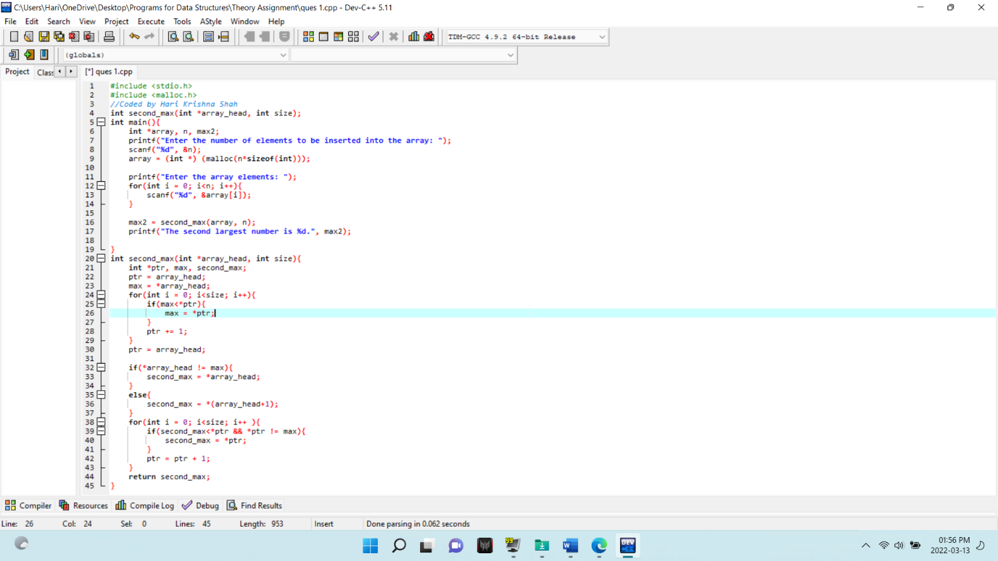

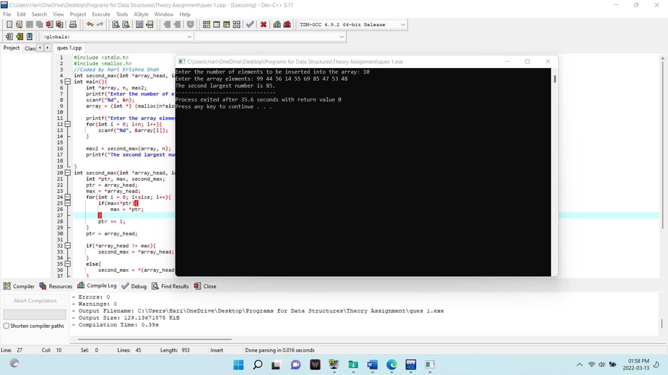

Ques 2. Consider an array MARKS[20][5] which stores the marks obtained by 20 students in 5 subjects. Now write a program to (a) find the average marks obtained in each subject. (b) find the average marks obtained by every student. (c) find the number of students who have scored below 50 in their average. (d) display the scores obtained by every student

Answer:

#include <stdio.h>

*//Coded by Hari Krishna Shah*

**int** main**(){**

**int** MARKS**[**20**][**5**],** average_for_student**[**20**]** **=** **{**0**},** average_marks**=** 0**,** scored_below **=** 0**;**

**int** subject_average**[**5**]={**0**},** sum_for_student **=** 0**,** sum_subject_average **=** 0**,** sum_marks **=** 0**,** total_for_student**[**20**]** **=** **{**0**};**

**for(int** i **=** 0**;** i**<**20**;** i**++){**

printf**("Enter the marks scored by student number %d in 5 subjects: ",** i**+**1**);**

**for(int** j **=** 0**;** j**<**5**;** j**++){**

scanf**("%d",** **&**MARKS**[**i**][**j**]);**

**}**

**}**

**for(int** i **=** 0**;** i**<**20**;** i**++){**

**for(int** j **=** 0**;** j**<**5**;** j**++){**

sum_for_student **+=** MARKS**[**i**][**j**];**

**}**

total_for_student**[**i**]** **=** sum_for_student**;**

average_for_student**[**i**]** **=** sum_for_student**/**5**;**

sum_for_student **=** 0**;**

**}**

**for(int** i **=** 0**;** i**<**20**;** i**++){**

**for(int** j **=** 0**;** j**<**5**;** j**++){**

sum_marks **+=** MARKS**[**i**][**j**];**

**}**

average_marks **=** sum_marks**/**100**;**

**}**

**for(int** j **=** 0**;** j**<**5**;** j**++){**

**for(int** i **=** 0**;** i**<**20**;** i**++){**

sum_subject_average **+=** MARKS**[**i**][**j**];**

**}**

subject_average**[**j**]** **=**sum_subject_average**/**20**;**

sum_subject_average **=** 0**;**

**}**

**for(int** i **=** 0**;** i**<**20**;** i**++){**

**if(**average_for_student**[**i**]<**50**){**

scored_below **+=** 1**;**

**}**

**}**

printf**("\n");**

**for(int** i **=** 0**;** i**<**5**;** i**++){**

printf**("The average marks scored in subject number %d is: %d\n",** i**+**1**,** subject_average**[**i**]);**

**}**

printf**("\n");**

printf**("The average score of the class per subject is %d.\n",** average_marks**);**

printf**("The number of student whose average is less than 50 is %d.\n\n",** scored_below**);**

**for(int** i **=** 0**;** i**<**20**;** i**++){**

printf**("The marks scored by student number %d is given below: \n",** i**+**1**);**

**for(int** j **=** 0**;** j**<**5**;** j**++){**

printf**("Marks for subject number %d is %d.\n",** j**+**1**,** MARKS**[**i**][**j**]);**

**}**

printf**("The total marks scored by student number %d is %d.\n",** i**+**1**,** total_for_student**[**i**]);**

printf**("The average marks scored by student number %d is %d.\n",** i**+**1**,** average_for_student**[**i**]);**

printf**("\n");**

**}**

**return** 0**;**

**}**

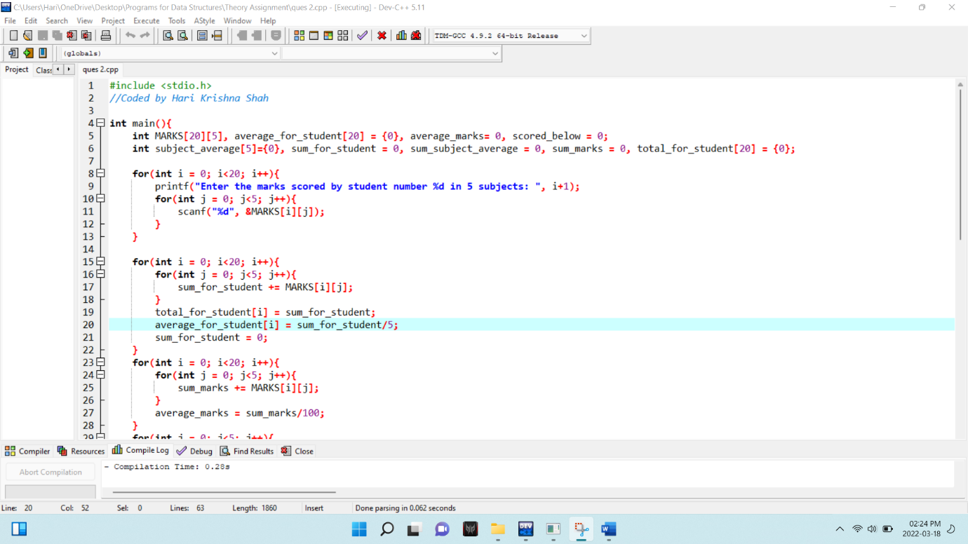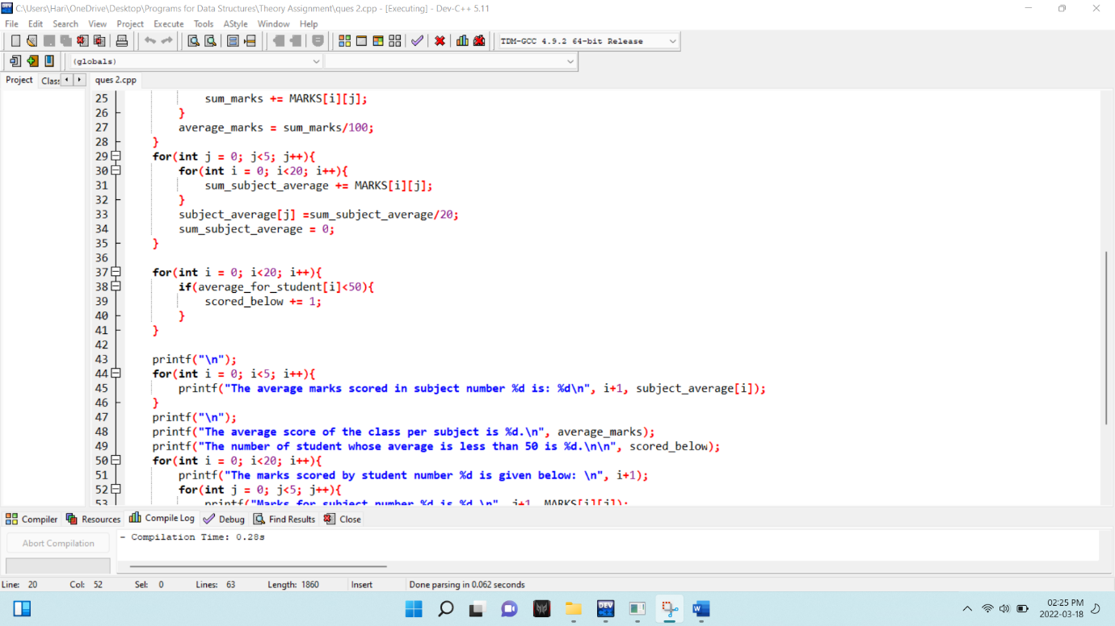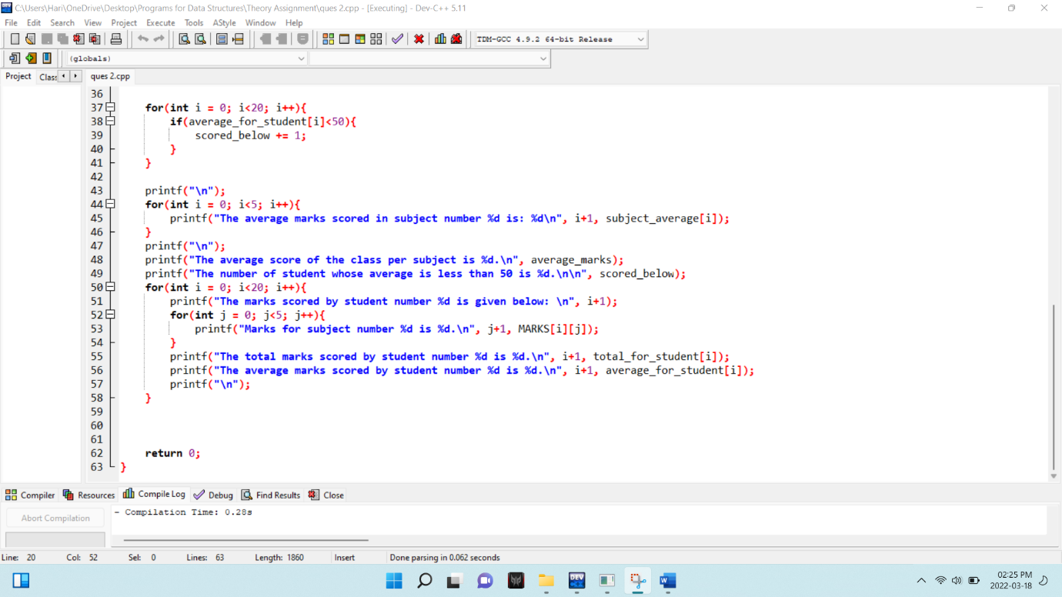

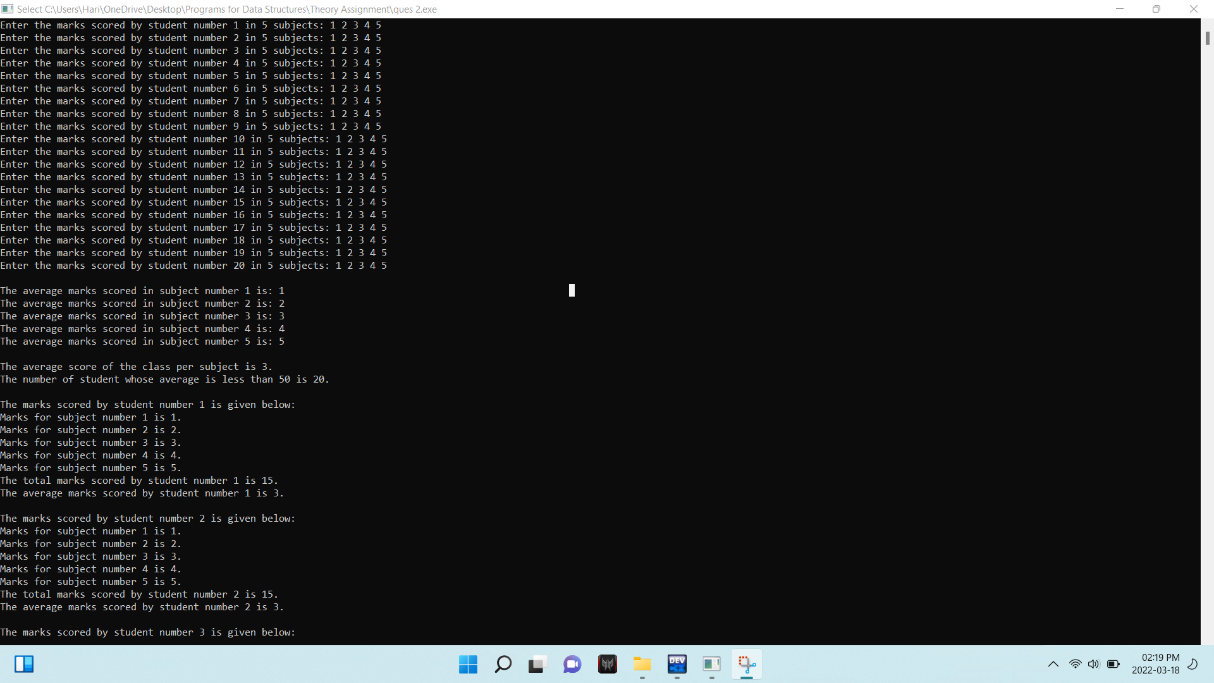

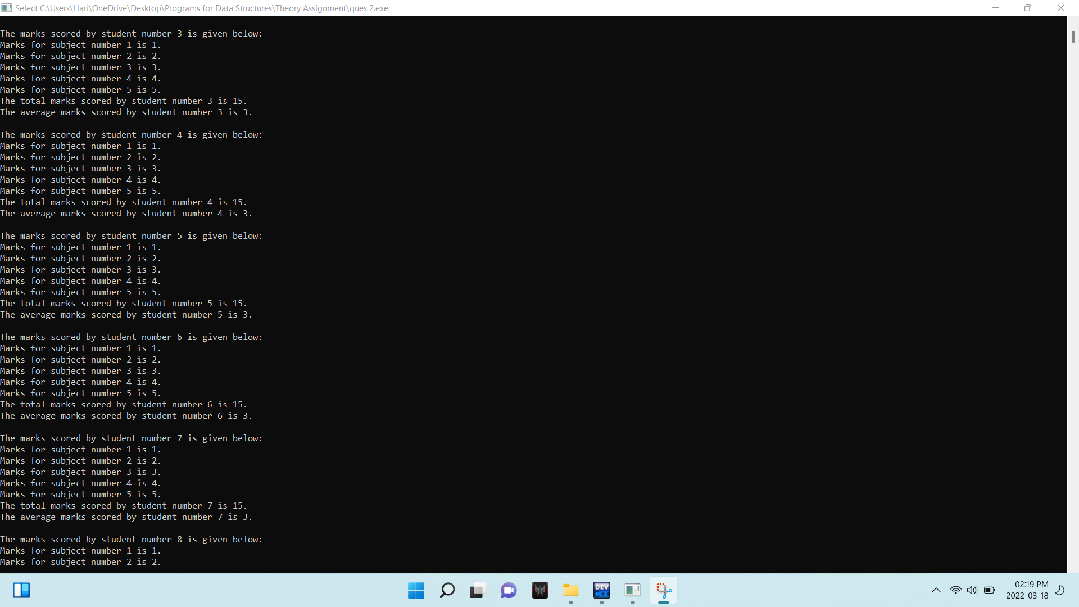

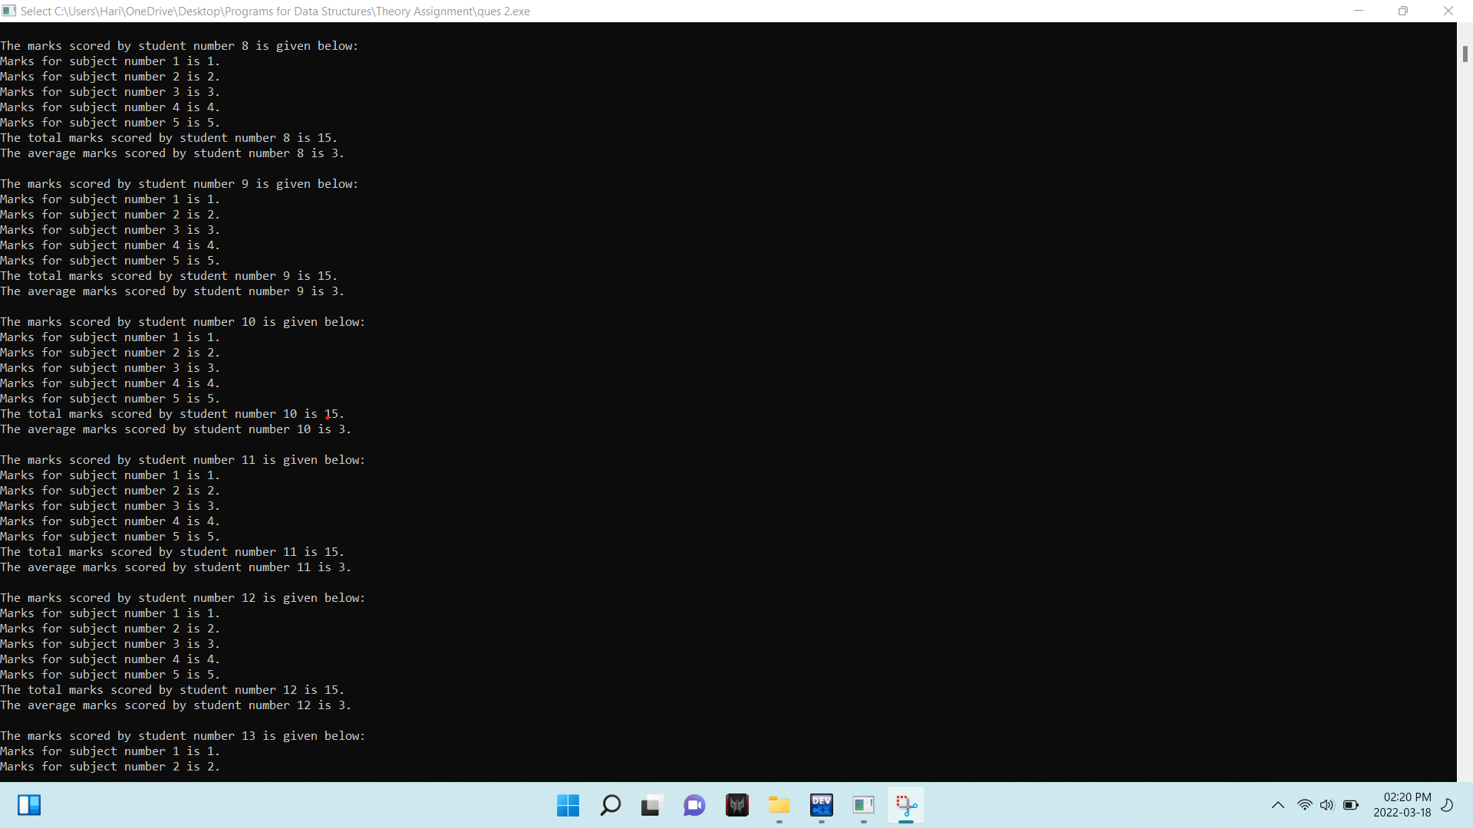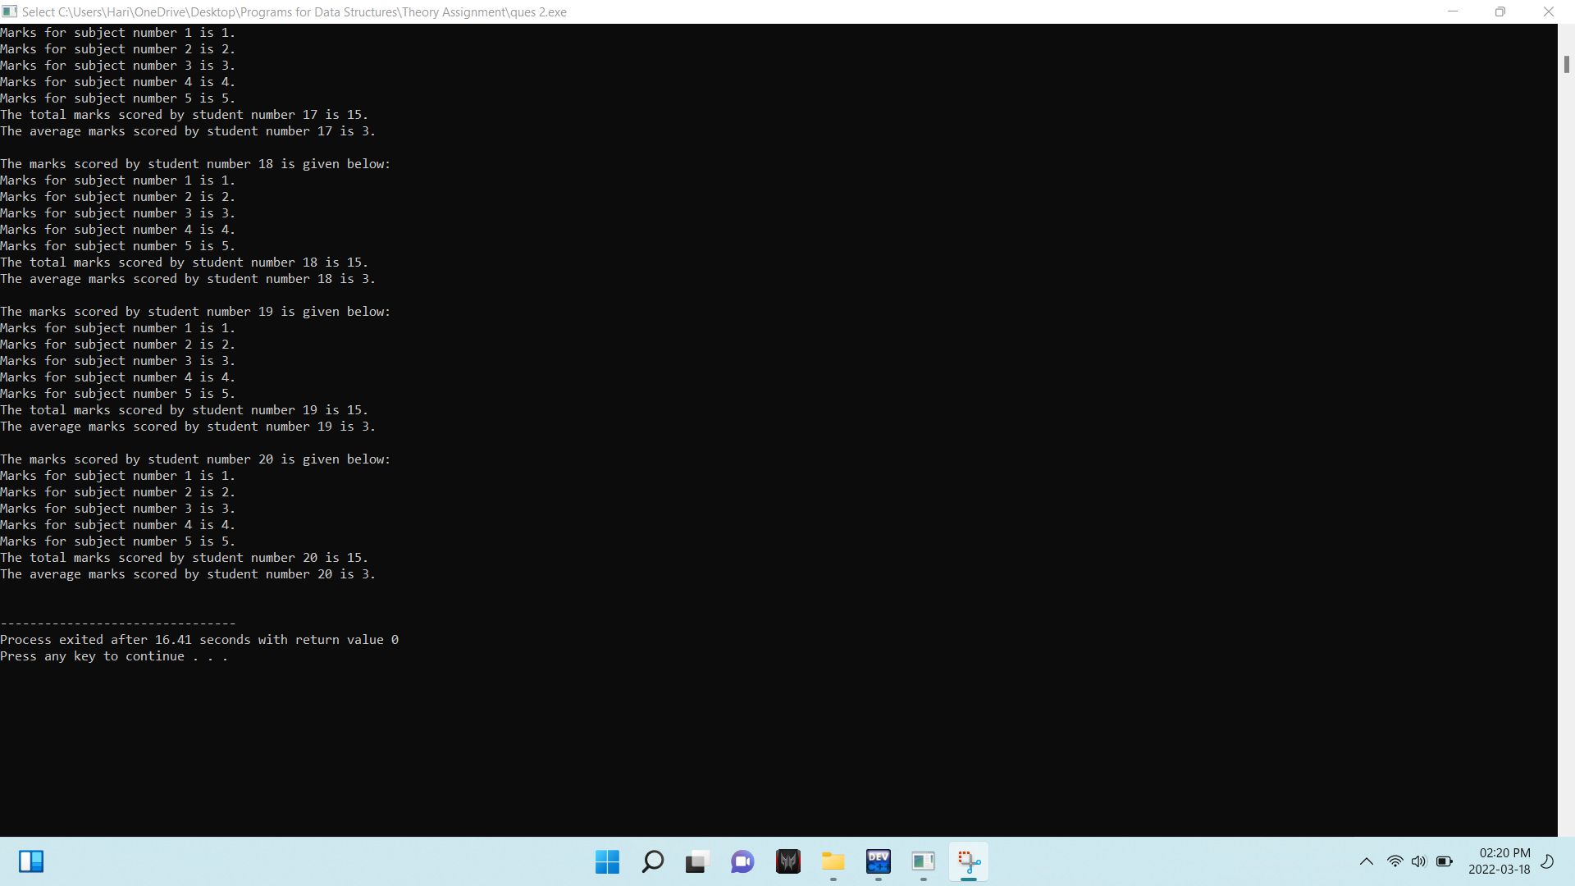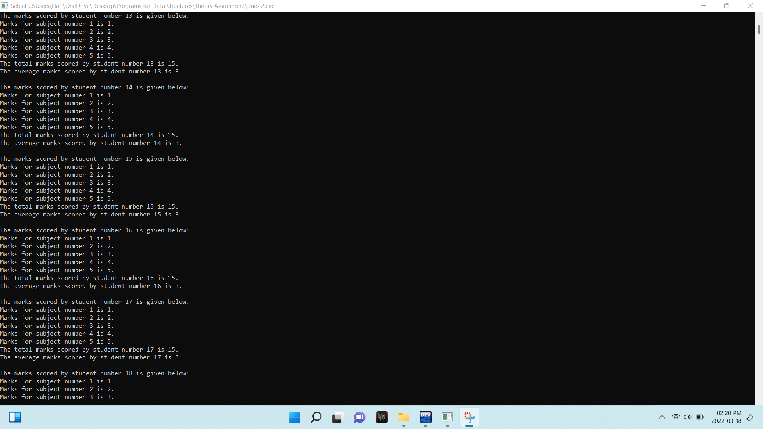

Ques 3. Write a program that reads an array of 100 integers. Display all the pairs of elements whose sum is 50.

Answer:

#include <stdio.h>

#include <malloc.h>

*//Coded by Hari Krishna Shah*

**int** main**(){**

**int** size**,** **\***array**,** check**;**

printf**("Enter the number of elements to be stored in the array: ");**

scanf**("%d",** **&**size**);**

array **=** **(int** **\*)** **(**malloc**(**size**\*sizeof(int)));**

printf**("Enter the array elements: ");**

**for(int** i **=** 0**;** i**<**size**;** i**++){**

scanf**("%d",** **&**array**[**i**]);**

**}**

**for(int** i **=** 0**;** i**<**size**;** i**++){**

**for(int** j **=** i**+**1**;** j**<**size**;** j**++){**

**if(**array**[**i**]+** array**[**j**]** **==** 50**){**

printf**("The number %d and %d which is at index %d and %d make a pair of exact 50.\n",** array**[**i**],** array**[**j**],** i**,** j**);**

check **=** 1**;**

**}**

**}**

**}**

**if(**check **==** 0**){**

printf**("The are no paris of elements in the array whose sum is 50.\n");**

**}**

**return** 0**;**

**}**

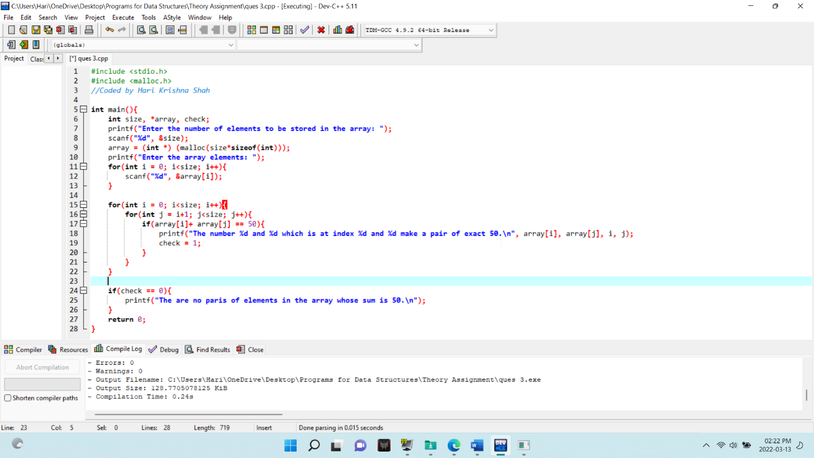

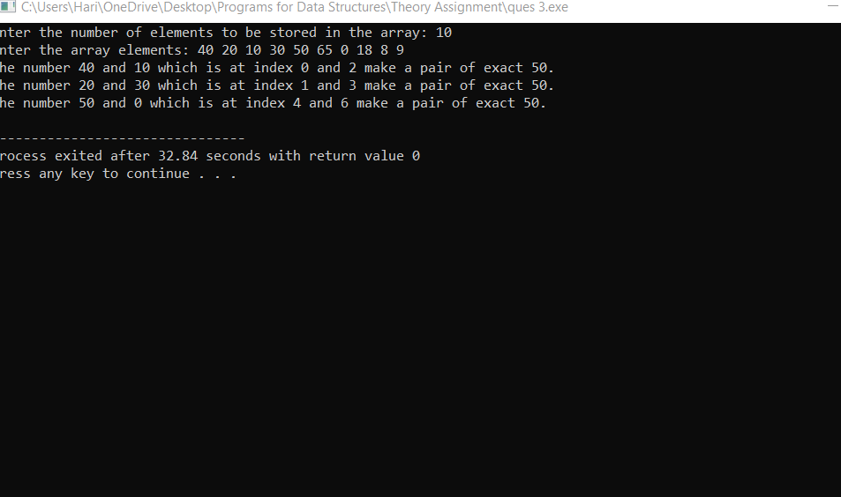

Ques 4 . Define a structure to store the name, an array marks[] which stores the marks of three different subjects, and a character grade. Write a program to display the details of the student whose name is entered by the user. Use the structure definition of the first question to make an array of students. Display the name of the students who have secured less than 40% of the aggregate.

Answer:

#include <stdio.h>

#include <string.h>

//coded by Hari Krishna Shah

**struct** student**{**

**char** name**[**100**];**

**int** marks**[**3**];**

**char** grade**[**3**];**

**float** aggregate**;**

**};**

**void** display**(struct** student temp**);**

**int** main**(){**

**int** size**,** temp1 **=** 0**,** temp2 **=** 0 **,**count **=** 0**,** count2 **=** 1**;**

**char** search**[**100**];**

printf**("Enter the number of students: ");**

scanf**("%d",** **&**size**);**

**struct** student s**[**size**];**

**for(int** i **=** 0**;** i**<**size**;** i**++){**

printf**("Enter the details of student number %d below.\n",** i**+**1**);**

printf**("Enter the name of student: ");**

scanf**("%s",** **&**s**[**i**].**name**);**

printf**("Enter the marks obtained in 3 subjects: ");**

**for(int** j **=** 0**;** j**<**3**;** j**++){**

scanf**("%d",** **&**s**[**i**].**marks**[**j**]);**

**}**

printf**("\n");**

**}**

**for(int** j **=** 0**;** j**<**size**;** j**++){**

**for(int** i **=** 0**;** i**<**3**;** i**++){**

temp1 **+=** s**[**j**].**marks**[**i**];**

**}**

temp2 **=** temp1**/**3**;**

s**[**j**].**aggregate **=** temp2**;**

**if(**temp2 **>**90**){**

strcpy**(**s**[**j**].**grade**,** **"A+");**

**}**

**else** **if(**temp2 **>**80**){**

strcpy**(**s**[**j**].**grade**,** **"A");**

**}**

**else** **if(**temp2 **>**70**){**

strcpy**(**s**[**j**].**grade**,** **"B+");**

**}**

**else** **if(**temp2 **>**60**){**

strcpy**(**s**[**j**].**grade**,** **"B");**

**}**

**else** **if(**temp2 **>**50**){**

strcpy**(**s**[**j**].**grade**,** **"C+");**

**}**

**else** **if(**temp2 **>**40**){**

strcpy**(**s**[**j**].**grade**,** **"C");**

**}**

**else{**

strcpy**(**s**[**j**].**grade**,** **"C");**

count **+=** 1**;**

**}**

temp1 **=** 0**;**

**}**

**if(**count **==** 0**){**

printf**("There is no one in the class whose agrregate is below 40.\n\n");**

**}**

**else{**

printf**("This are the students whose aggregate is less than 40.\n");**

**for(int** i **=** 0**;** i**<**size**;** i**++){**

**if(**s**[**i**].**aggregate**<**40**){**

printf**("%d. %s\n",** count2**,** s**[**i**].**name**);**

count2 **+=** 1**;**

**}**

**}**

printf**("\n");**

**}**

printf**("Enter the name of student to search: ");**

scanf**("%s",** **&**search**);**

**for(int** i **=** 0**;** i**<**size**;** i**++){**

**if(**strcmp**(**s**[**i**].**name**,** search**)** **==** 0**){**

display**(**s**[**i**]);**

**}**

**}**

**}**

**void** display**(struct** student temp**){**

printf**("The details of the student is given below.\n");**

printf**("Name: %s\n",** temp**.**name**);**

**for(int** j **=** 0**;** j**<**3**;** j**++){**

printf**("Marks for subject number %d: %d\n",** j**+**1**,** temp**.**marks**[**j**]);**

**}**

printf**("Grade: %s\n",** temp**.**grade**);**

printf**("Aggregate: %.0f%%.\n",** temp**.**aggregate**);**

**}**

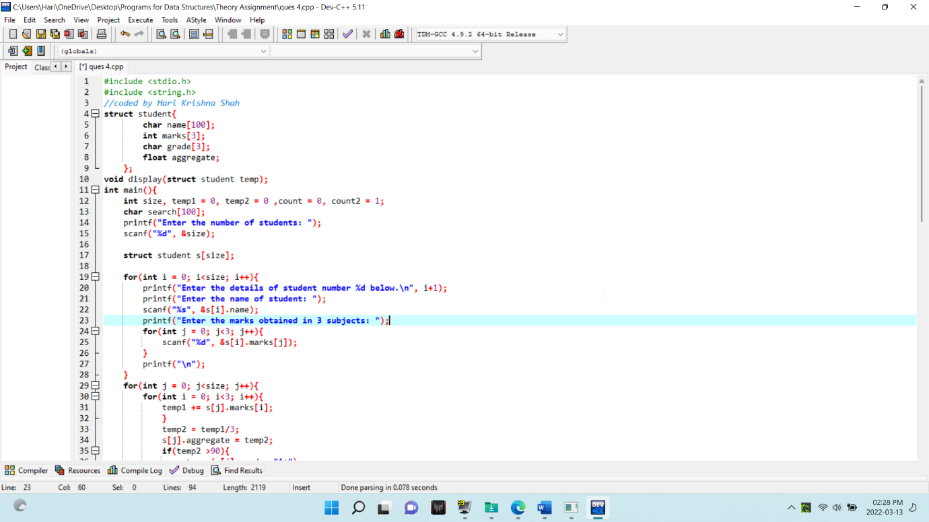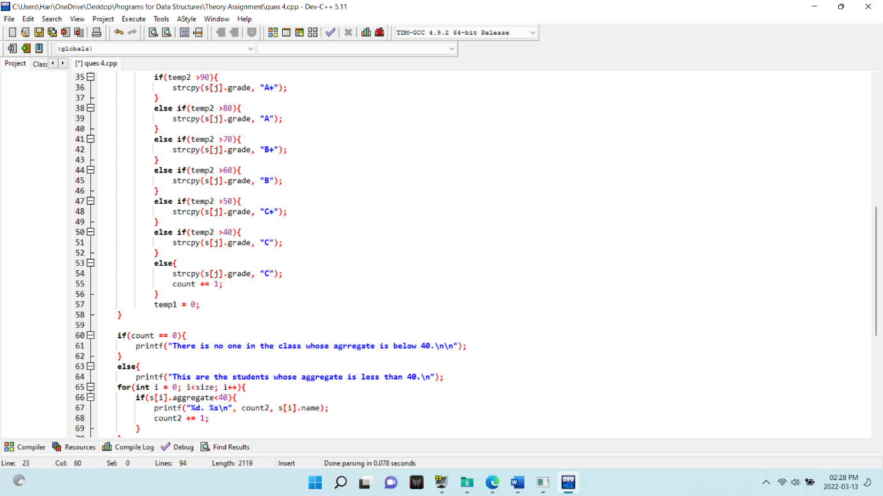

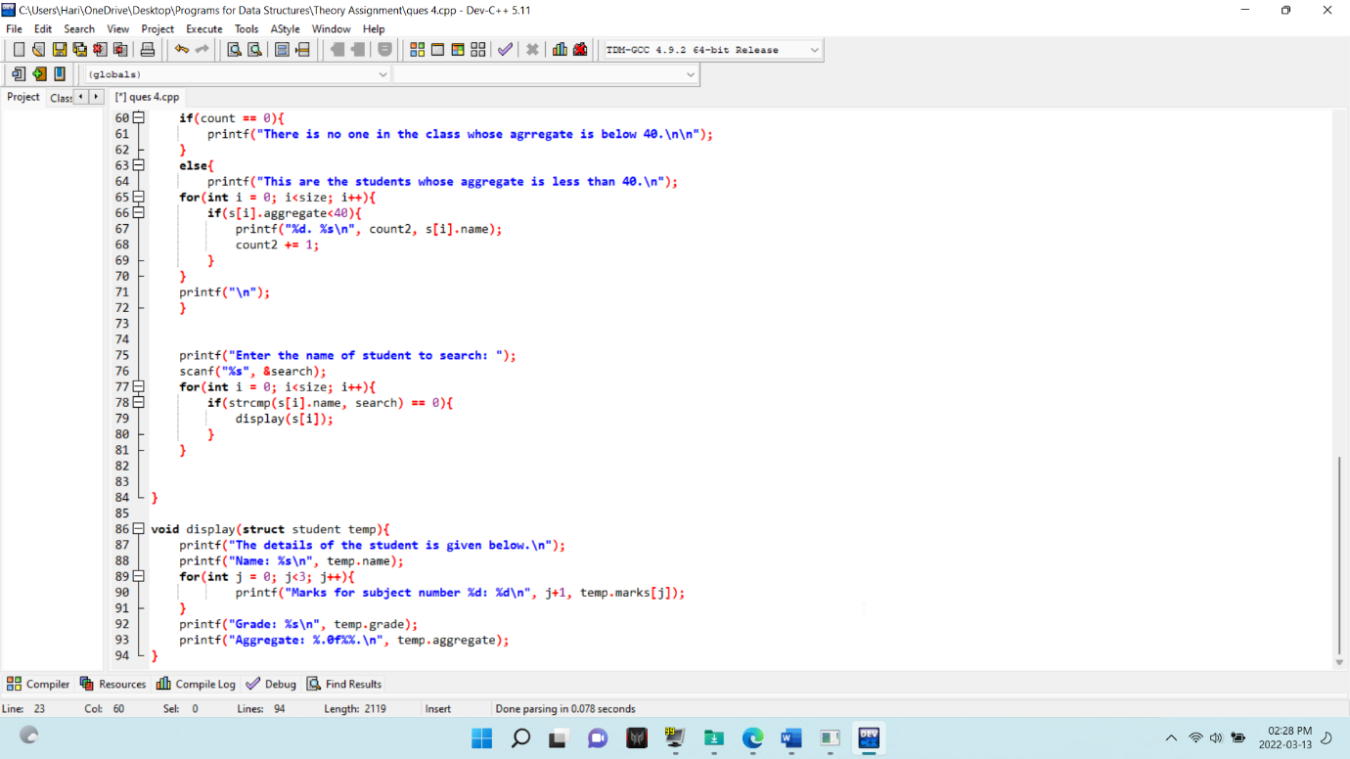

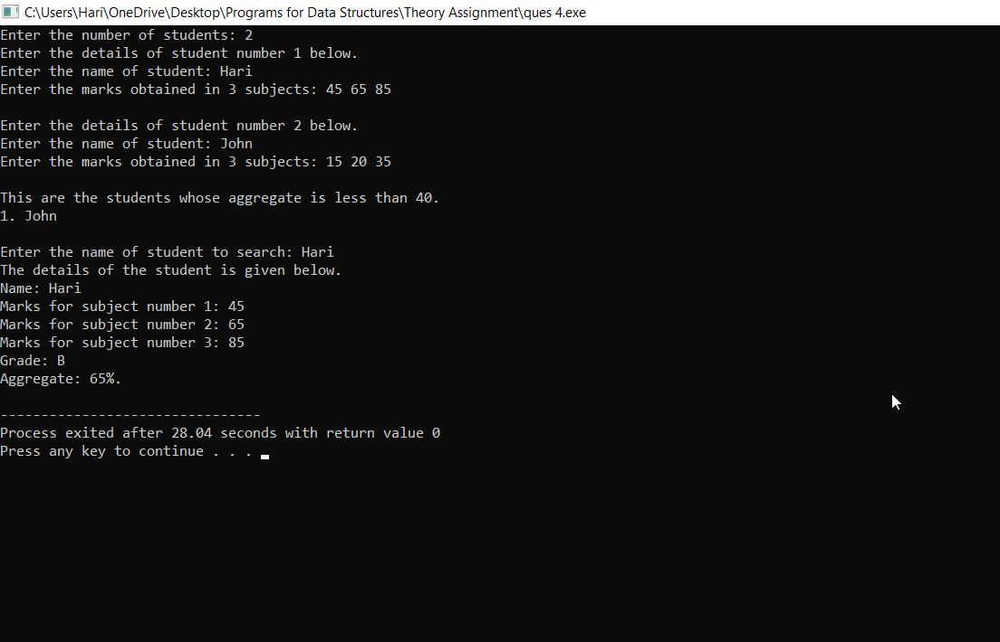

Ques 5. Write a program to create a structure with the information given below. Then, read and print the data. Use the pointer objects. Employee[10] (a) Emp_Id (b) Name (i) First Name (ii) Middle Name (iii) Last Name (c) Address (i) Area (ii) City (iii) State (d) Age (e) Salary (f) Designation.

Answer:

#include <stdio.h>

#include <string.h>

#include <malloc.h>

*//Coded by Hari Krishna Shah*

**struct** Employee_details**{**

**char** EMP_Id**[**20**];**

**struct** Name**{**

**char** first_name**[**30**];**

**char** middle_name**[**30**];**

**char** last_name**[**30**];**

**}**name**;**

**struct** Address**{**

**char** area**[**30**];**

**char** city**[**30**];**

**char** state**[**30**];**

**}**address**;**

**int** age**;**

**int** salary**;**

**char** designation**[**30**];**

**};**

**int** main**(){**

**struct** Employee_details **\***Employee**;**

Employee **=** **(struct** Employee_details **\*)** **(**malloc**(**10 **\*** **sizeof(struct** Employee_details**)));**

**for(int** i**=** 0**;** i**<**10**;** i**++){**

printf**("Enter the details of employee number %d below.\n",** i**+**1**);**

printf**("Enter the name of the employee below.\n");**

printf**("Enter the first name: ");**

scanf**("%s",** **&**Employee**[**i**].**name**.**first_name**);**

printf**("Enter the middle name: ");**

scanf**("%s",** **&**Employee**[**i**].**name**.**middle_name**);**

printf**("Enter the last name: ");**

scanf**("%s",** **&**Employee**[**i**].**name**.**last_name**);**

printf**("Enter the area: ");**

scanf**("%s",** **&**Employee**[**i**].**address**.**area**);**

printf**("Enter the city: ");**

scanf**("%s",** **&**Employee**[**i**].**address**.**city**);**

printf**("Enter the state: ");**

scanf**("%s",** **&**Employee**[**i**].**address**.**state**);**

printf**("Enter the age: ");**

scanf**("%d",** **&**Employee**[**i**].**age**);**

printf**("Enter the salary: ");**

scanf**("%d",** **&**Employee**[**i**].**salary**);**

printf**("Enter the designation: ");**

scanf**("%s",** **&**Employee**[**i**].**designation**);**

printf**("\n");**

**}**

**for(int** i**=** 0**;** i**<**10**;** i**++){**

printf**("The details of employee number %d below.\n",** i**+**1**);**

printf**("Employee's full name is below.\n");**

printf**("First name: %s\n",** Employee**[**i**].**name**.**first_name**);**

printf**("Middle name: %s\n",** Employee**[**i**].**name**.**middle_name**);**

printf**("Last name: %s\n",** Employee**[**i**].**name**.**last_name**);**

printf**("Employee's Address is below.\n");**

printf**("Area: %s\n",** Employee**[**i**].**address**.**area**);**

printf**("City: %s\n",** Employee**[**i**].**address**.**city**);**

printf**("State: %s\n",** Employee**[**i**].**address**.**state**);**

printf**("Age: %d\n",** Employee**[**i**].**age**);**

printf**("Salary: %d\n",** Employee**[**i**].**salary**);**

printf**("Designation: %s\n",** Employee**[**i**].**designation**);**

printf**("\n");**

**}**

**return** 0**;**

**}**



